# How to Create an Order

Step 1: Click on the Order Tab

Step 2: Click on the Create New order Button.

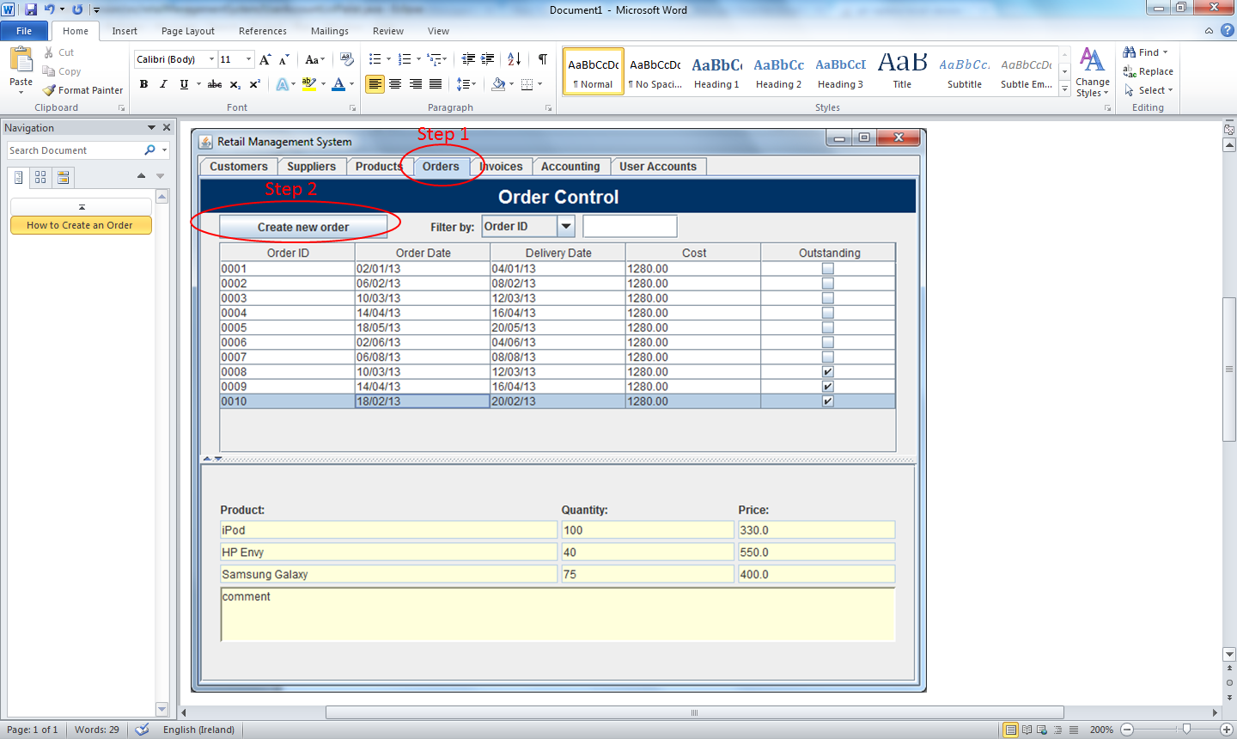

Step 3: Select a Supplier using the supplier Combo Box at the top handle left corner of your screen

Step 4: Chose a Product by using the Product Combo Box and also select the Quantity using Quantity Combo Box.

Note: The unit Price and Price of the Product is displayed and the Price of the product selected is calculated based on the quantity chosen.

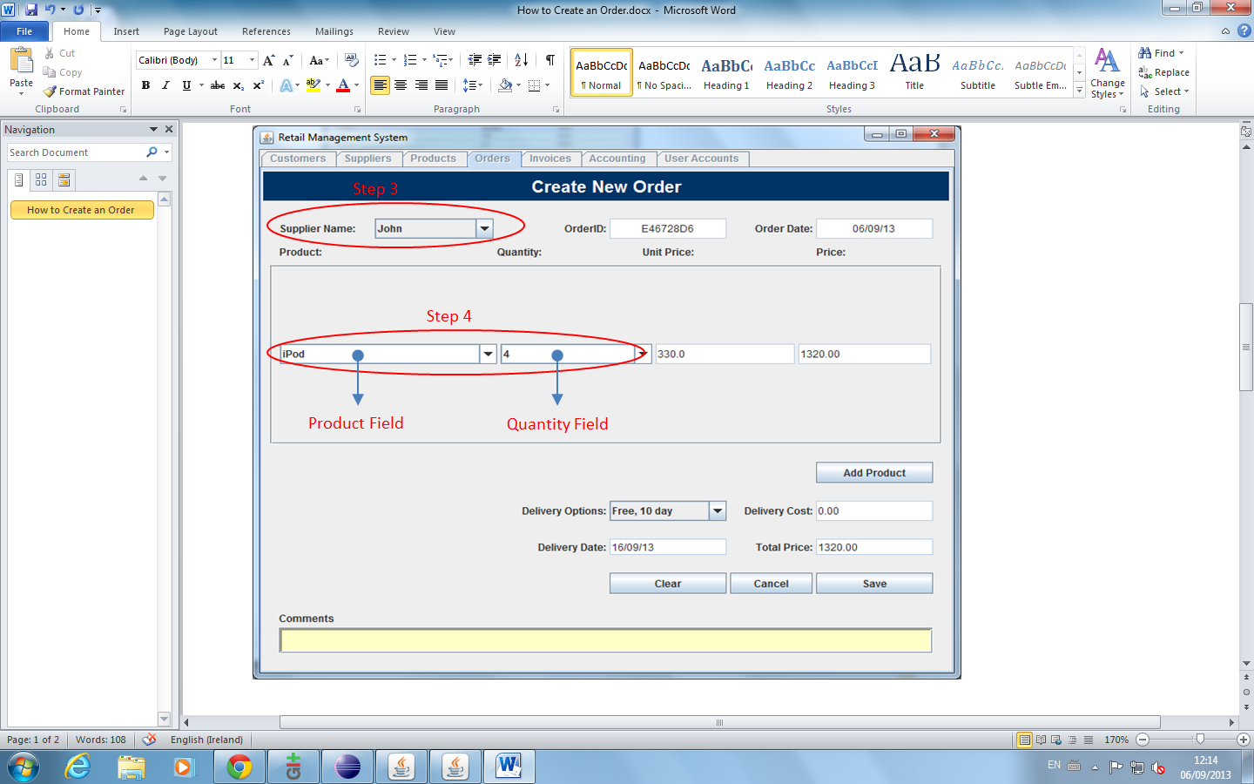

**Add List of Product to Order**

You add an number of product by Clicking on the Add Product Button,

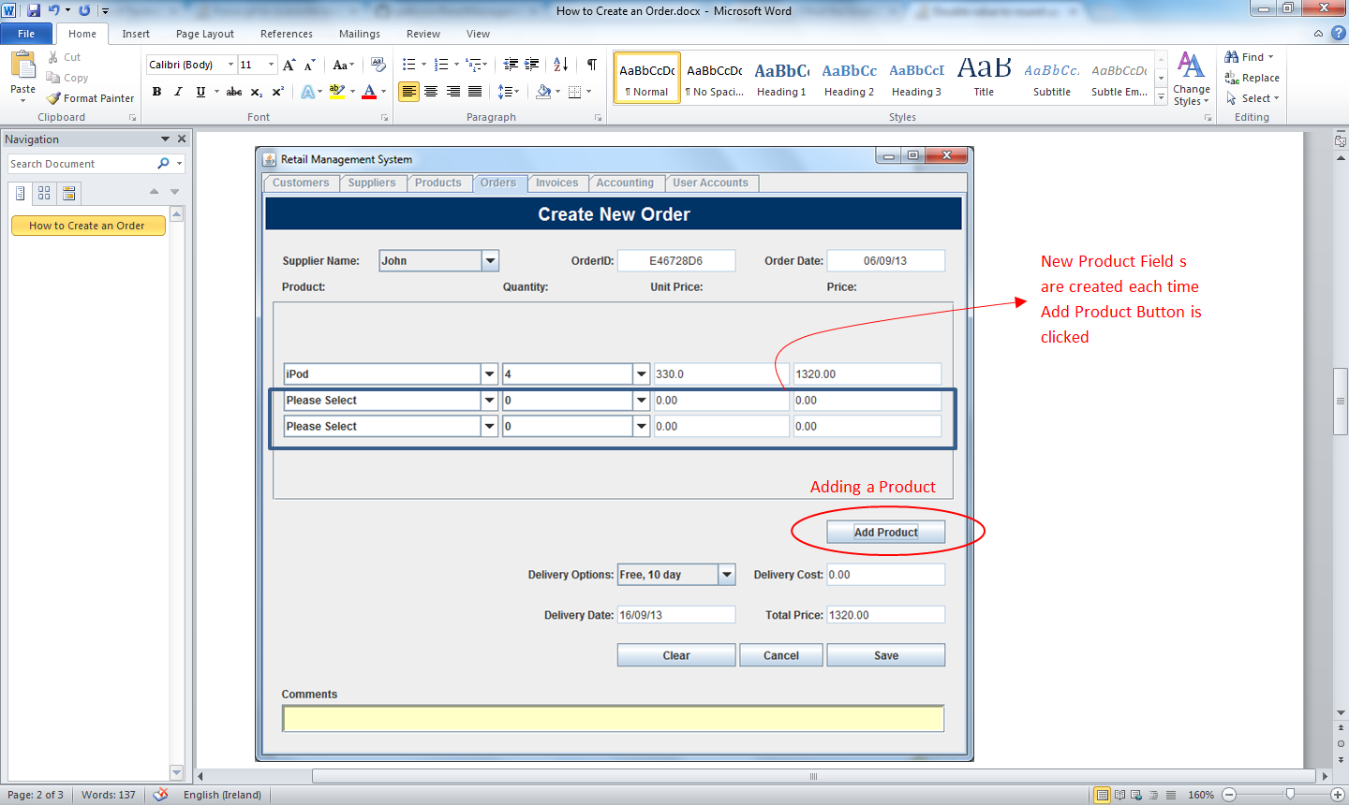

Step 5: Select a Delivery Option, using Delivery Option Combo Box but the Delivery Option default is free 10 days delivery.

Note: The delivery date, delivery cost and Total Cost of Order are displayed . You must select a supplier, a product & its quantity to proceed with Order.

Step 6: Click Save Button to Confirm Order and it Exit to Order Table

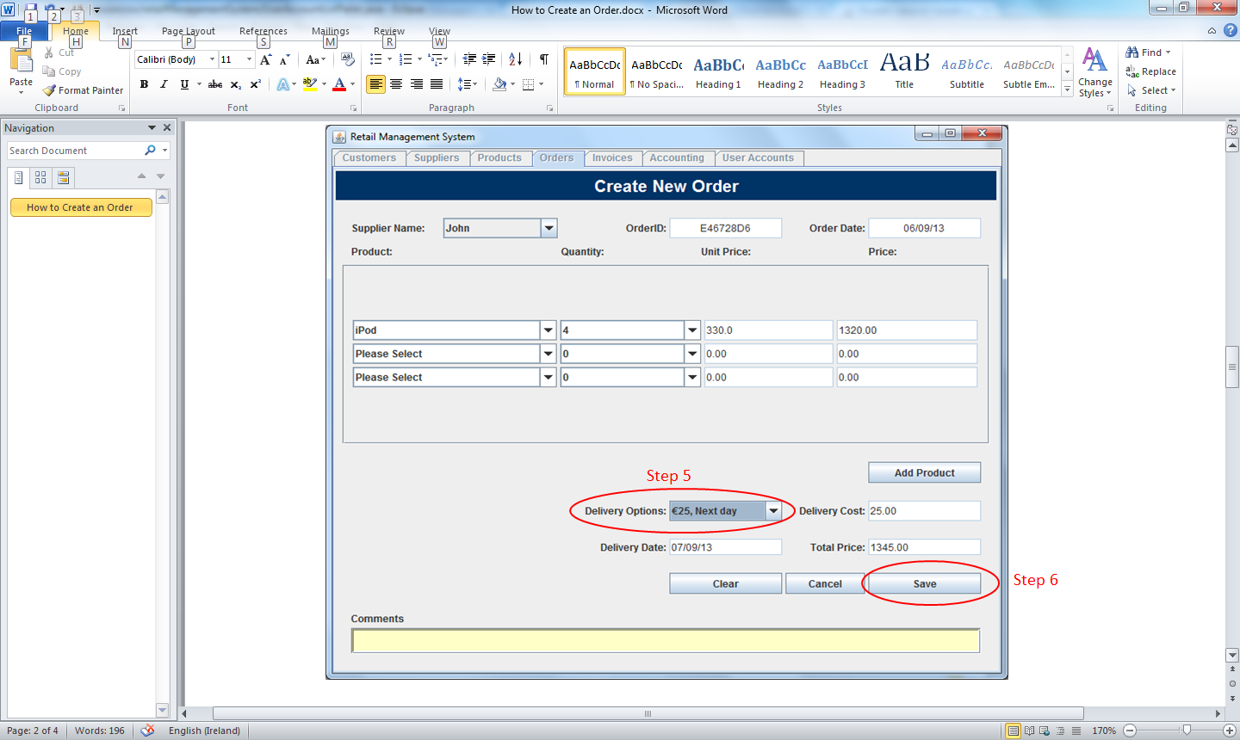

To restart Order Click Clear Button

To Exit Click the Cancel Button to Exit

Add comments to Order using the Comment Text Area Field, if needed.

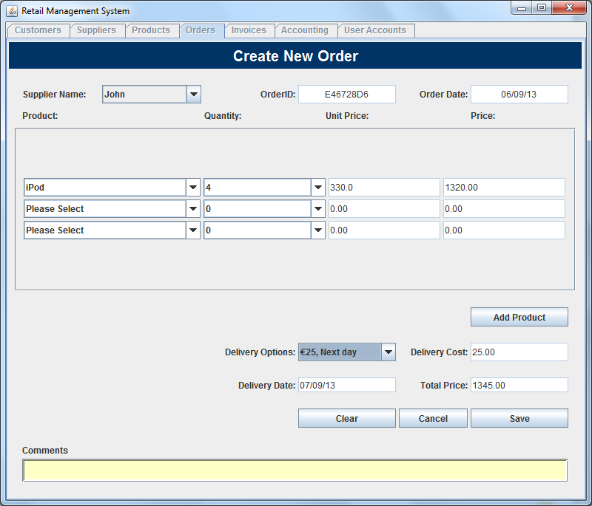

# How to Use Order Table

Step 1: To view Order table Click on the Order Tab

Note: The order table shows the Order ID, Order Date, Order Cost and Outstanding for the Order.

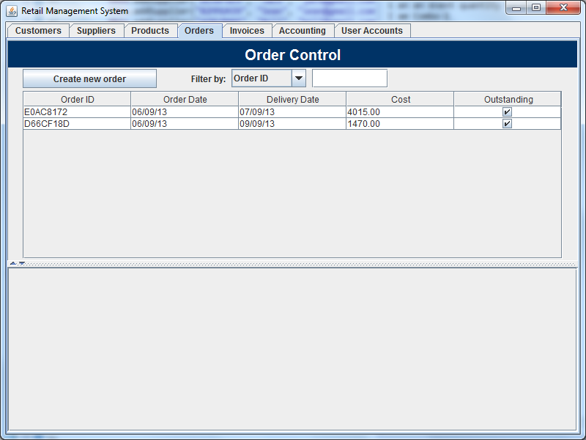

**Step 2:** Select an Order in the Table to Display the Products Ordered, Quantity, Price and Order Comment on the panel below.

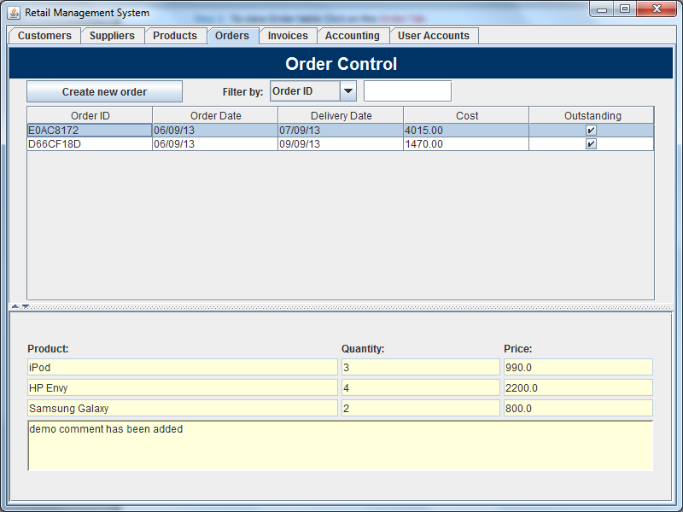

An Order was selected

Products Ordered, Quantity, Price and comment is displayed

To view a specific Order use the Filter or Search to find Order.

**Step 3:** Use the Filter by Combo Box to select the table field to Filtered

**Step 4:** Enter the information to be filtered in the Text Field, related to selected table field.

Your search is show on the table below.

Therefore it possible to view current order and old orders by filtering the table

Filter by Table Field and Search

